Java Project

Online shopping system: Creating a shop manager system to help with efficient functioning of the shop its deployed in. It provides necessary features to help various entities. There are 3 profiles in the application: customer, shop inventory, shop keeper.

Team members:

Saurabh Yadav – PES2UG19CS371

Shreyas G - PES2UG19CS387

Sapna Singh - PES2UG19CS366

Satwik Bansal - PES2UG19CS470

Class Diagram:

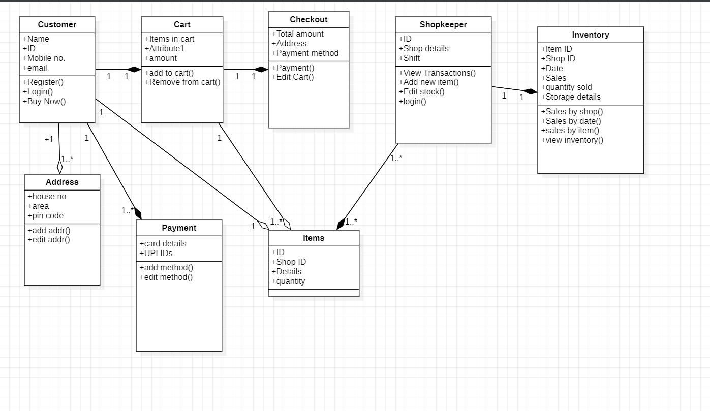

Use Case:

